Oberon Ilano

CS 447

Lab #9

**1.**

CREATE ASSERTION digitLimit CHECK

(NOT EXISTS (

SELECT model FROM Product

WHERE model > 999));

**2.**

CREATE ASSERTION laptopPrice CHECK

(NOT EXISTS (

SELECT price FROM Laptop

WHERE price > 0));

**3.**

CREATE TRIGGER updatePC

BEFORE UPDATE ON PC

REFERENCING

OLD ROW AS OldTuple,

NEW ROW AS NewTuple

FOR EACH ROW

BEGIN

SELECT speed FROM PC

WHERE OldTuple.price < NewTuple.price;

IF OldTuple.speed = NewTuple.speed THEN EXIT

ELSE UPDATE PC

SET price = NewTuple.price AND speed = NewTuple.speed;

END;sc

**4.**

CREATE TRIGGER checkModel

AFTER INSERT ON Printer

REFERENCING

NEW ROW AS NewTuple

FOR EACH ROW

WHEN (NOT EXISTS

(SELECT Product.model FROM Product

WHERE NewTuple.model = Product.model))

BEGIN

DELETE FROM Printer where Printer.model = NewTuple.model;

END;

**5.**

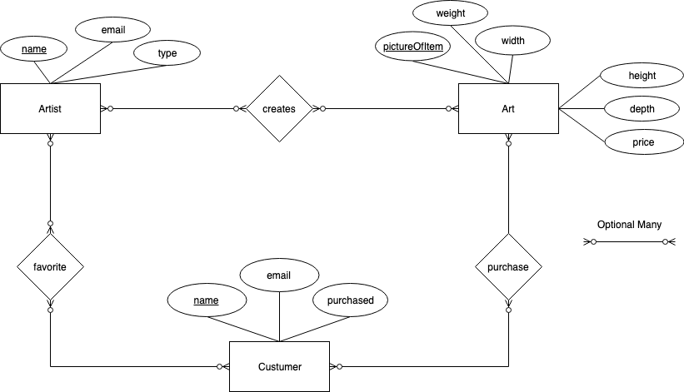

Artist(name, email, type)

Art(pictureOfItem, price, weight, width, height, depth)

Customer(name, email, purchased)

creates(ArtistName, pictureOfItem)

purchase(CustomerName, pictureOfItem)

favorite(ArtistName, CustomerName)

Artist: name  email

name, email  type

Art: pictureOfItem  weight, width, height, depth, price

Customer: name  email

name, email  type;

